**Prestige School**

**Developer Guide**

|  |  |  |
| --- | --- | --- |
| **Supervisor:** | Sir Farhan Ali Shah |  |
| **Batch:** | 2410G2 |  |
| **Group:** | C |  |
| **Serial no.** | **Enrollment number** | **Student Name** |
| 1. | *Student-* | Rahat Azeem |
| 2. | *Student-* | Yousuf Saleem |
| 3’. | *Student-* | Bilal Saleem |

**Prestige logo**

**Home (Index.html)**

Welcome to Prestige School! We're thrilled to have you here. Our mission is to provide a seamless experience as you explore top schools of your region. Whether you're looking for private or govt or simply want to discover something new, we’re here to make it easy and enjoyable. Dive in and find out what makes us stand out! Let’s embark on this journey together.

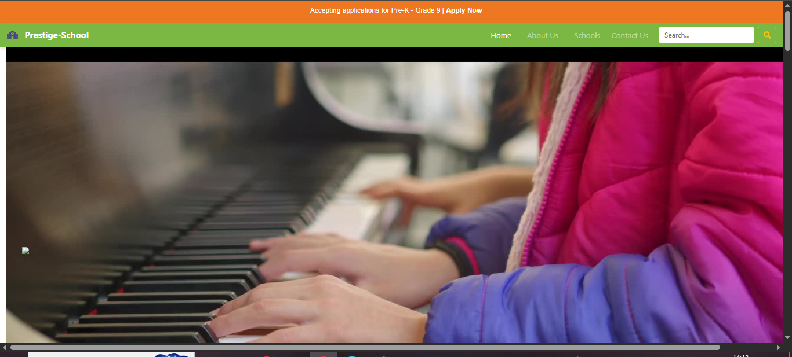

Figure 1: Home Page For Our News Website:

Featured Activity Section

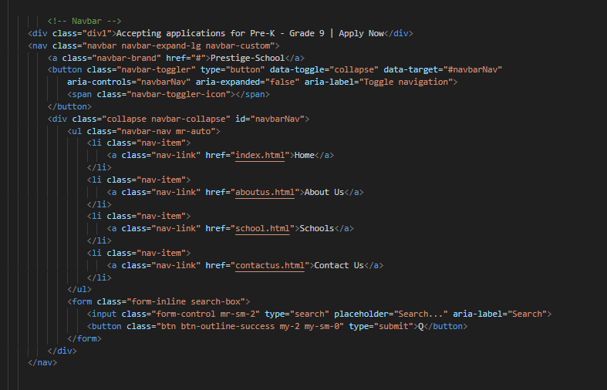



Featured Activity Section Code

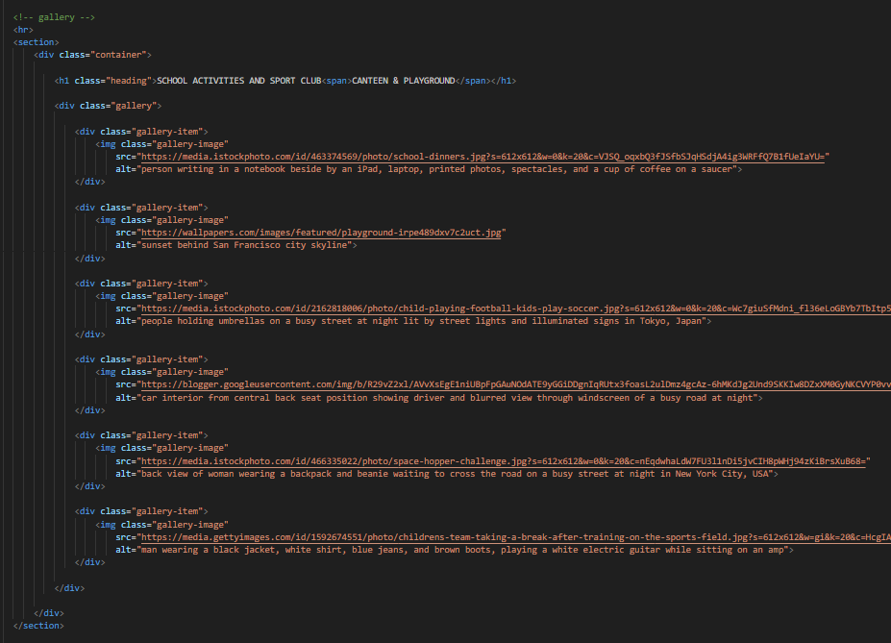

Review Section



Code of Card Section

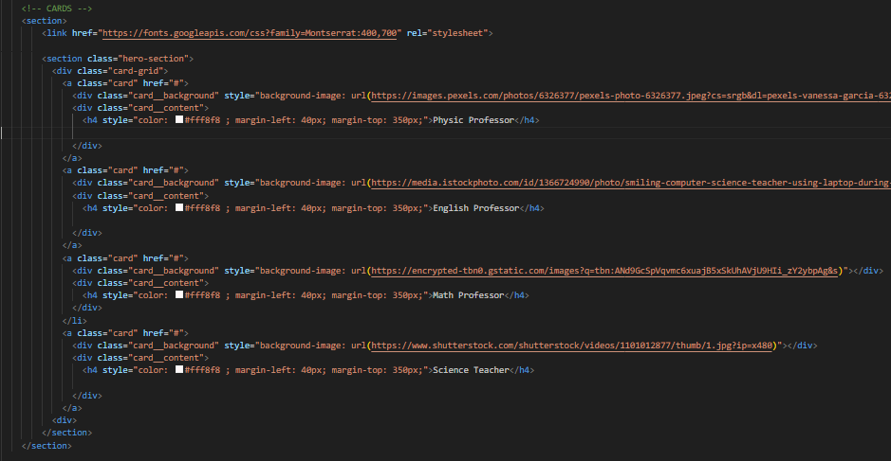

Cards Section



Animated Card Section

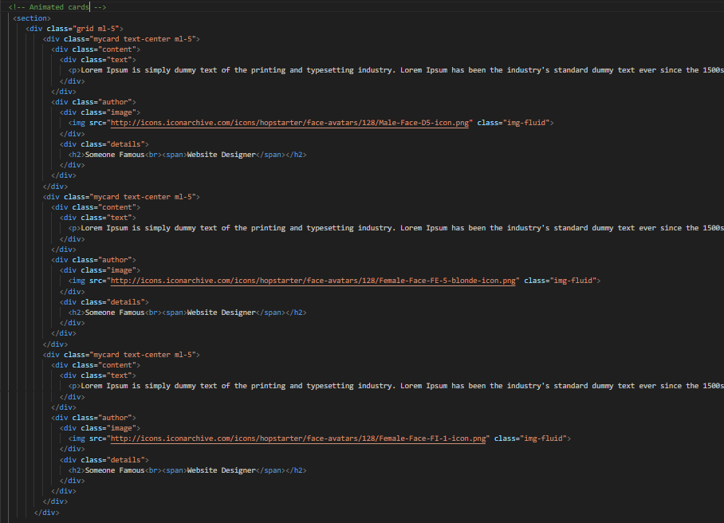

Meet Our Team

Footer

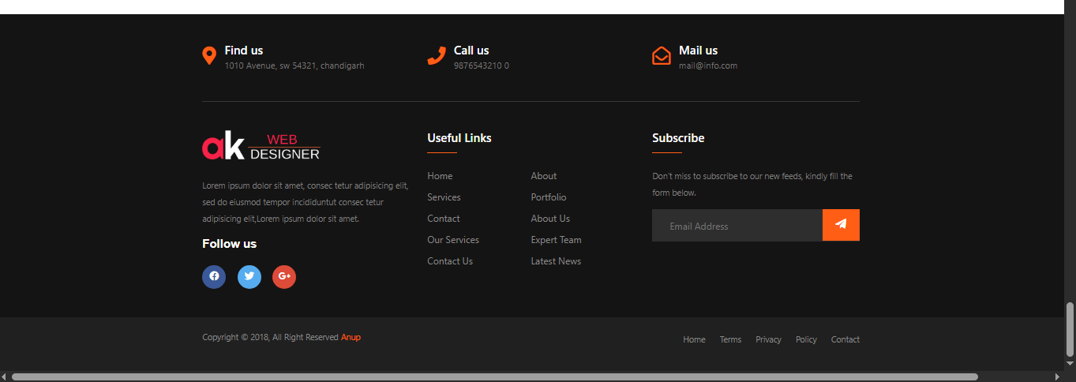

Code of Footer

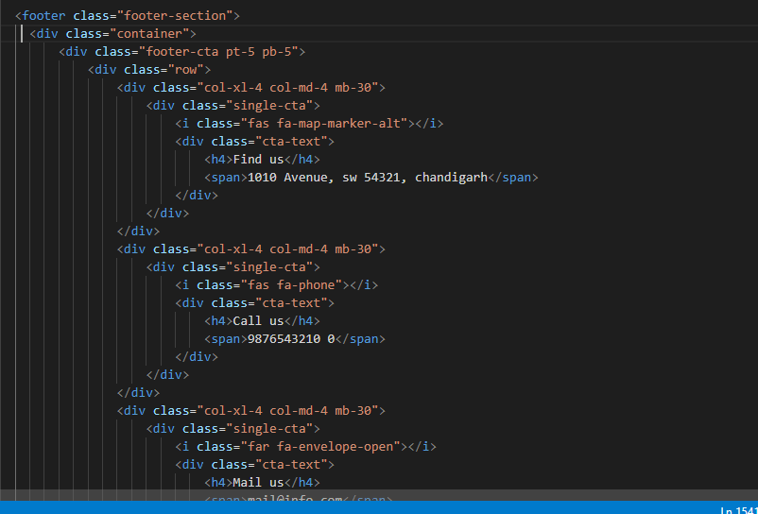

**About us Page**

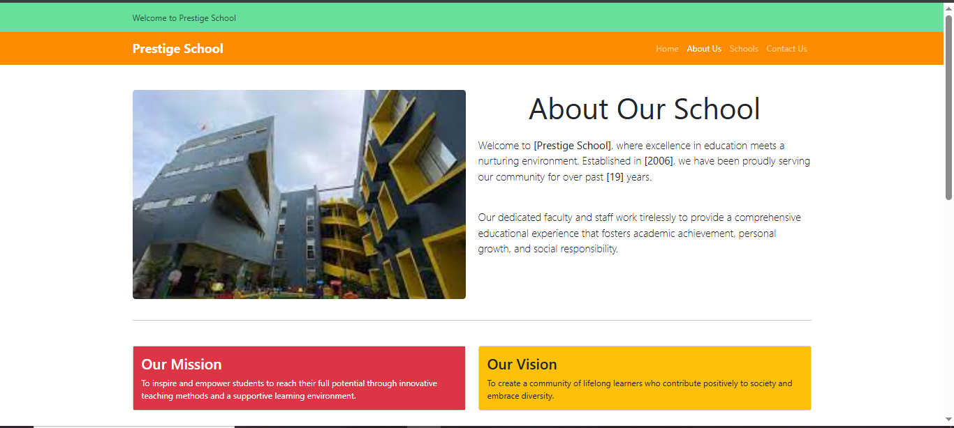

Code of About us

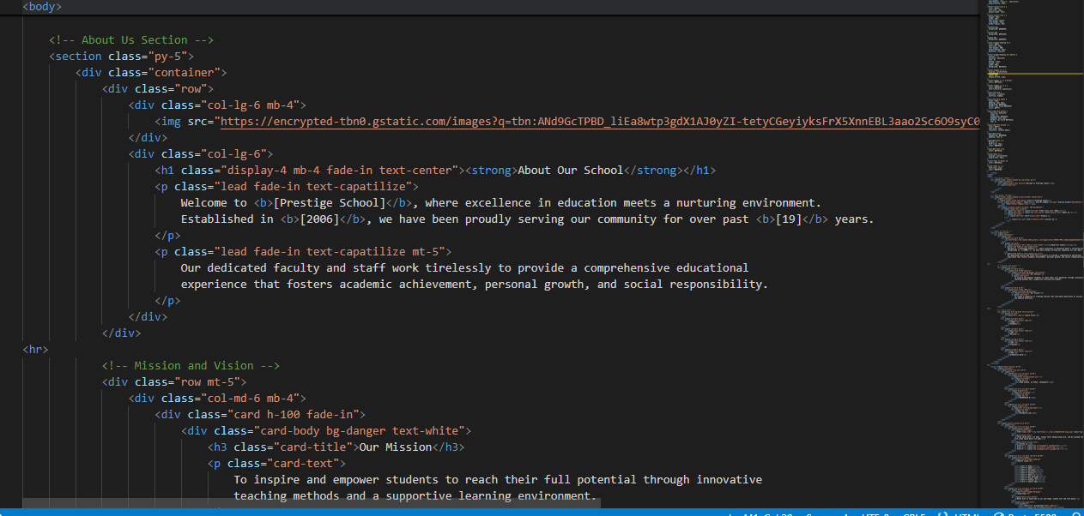

Schools Page

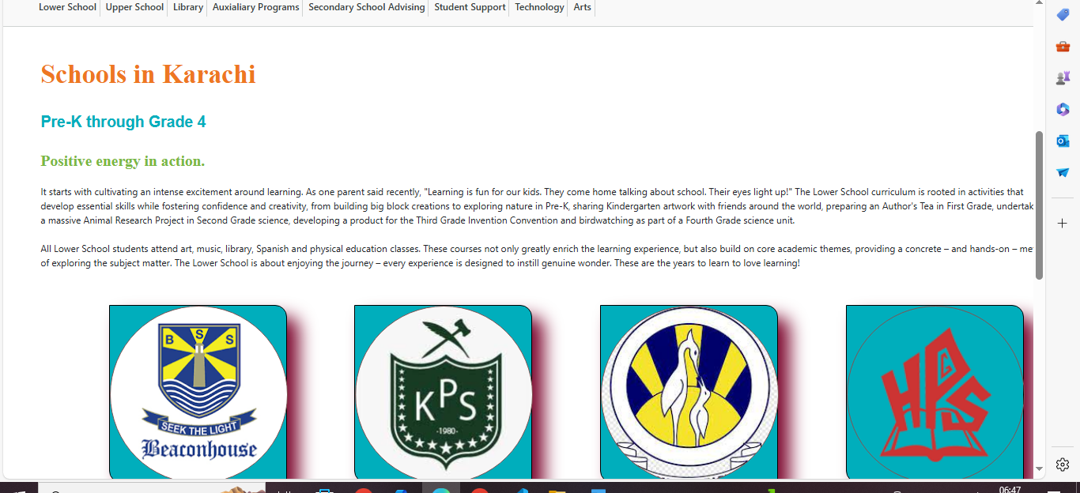

School Page Code

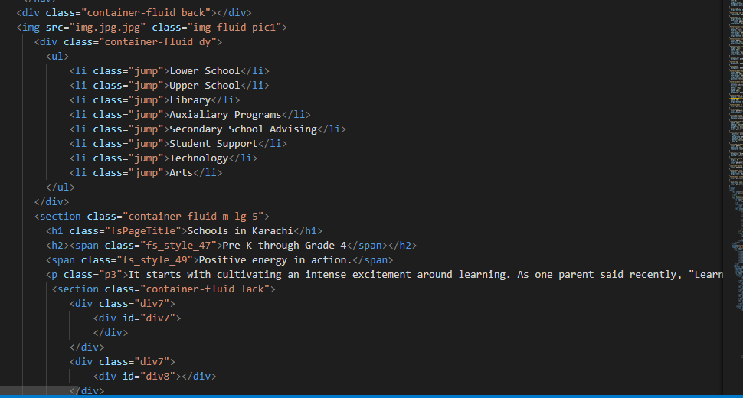

Contact us Page

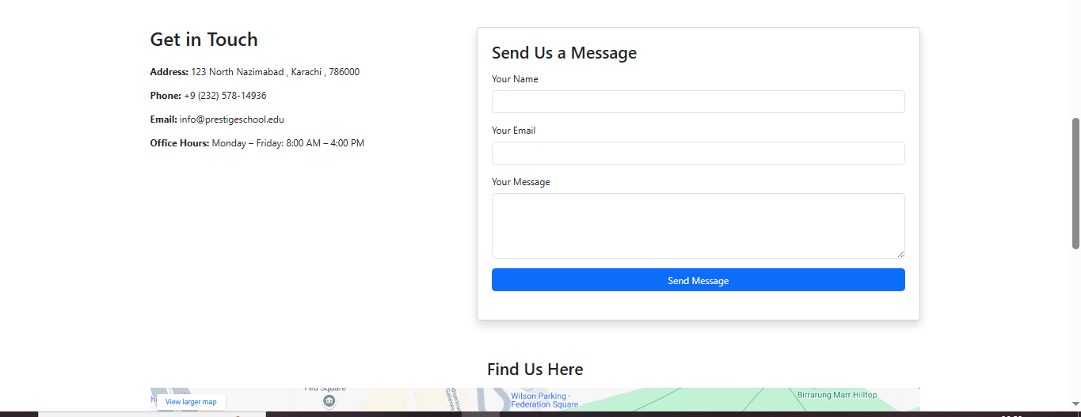

Contact us Code

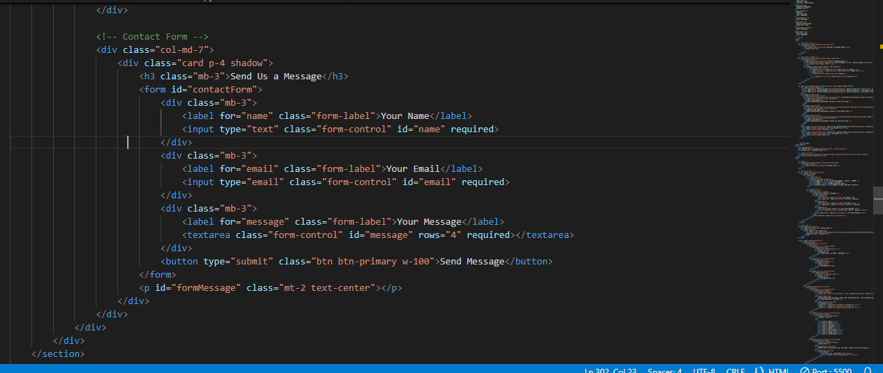

Google Maps

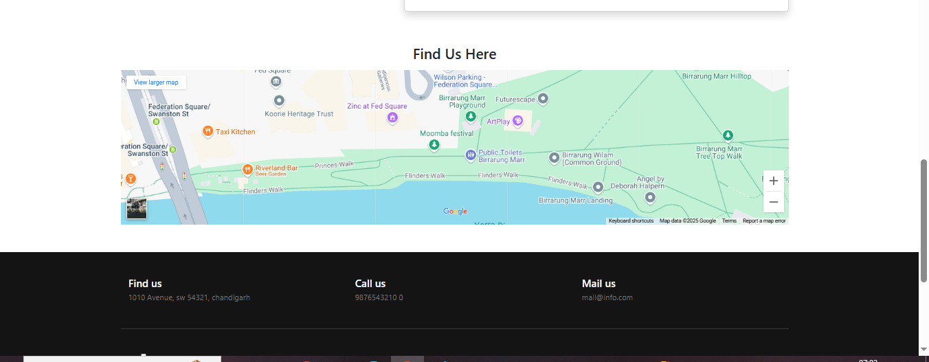

Google Maps Code

